



Atlantic Ocean

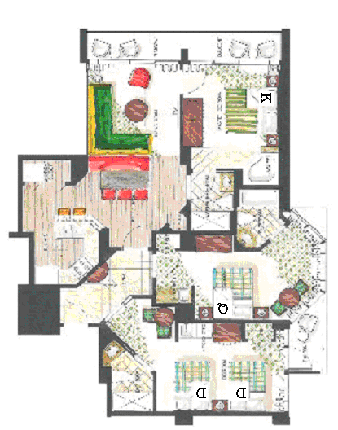
Suite
Entrance

Catalina Penthouse – 3 Bedroom Oceanfront Suite

I understand that Ocean Beach Club is a “float” suite resort and that I am purchasing a particular suite type. The Catalina Penthouse will sleep a maximum of 10 people and will trade for a suite that sleeps 8 people under our current exchange affiliation. The Catalina is a lock-off style of suite. You may separate this suite into a one-bedroom (sleeps 4) and two efficiencies (sleeps 2) any year you so desire. It has a double, furnished oceanfront balcony.
Initial Here

